CHS

AMERICAN SIGN LANGUAGE I

SPRING FINAL EXAM REVIEW 2019

Please use, review time in class, these review sheets and the moodle videos to review for your Spring Final Exam

Please email or see me, if you have any questions.

Ms. Baglietto

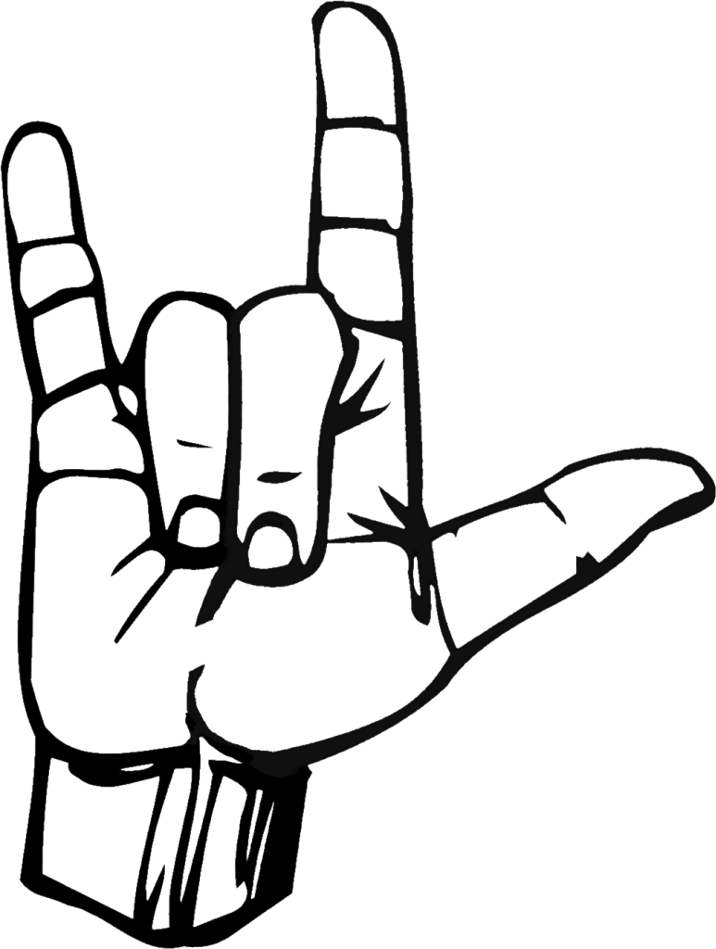

**4.1-4.7 Vocabulary Review**

boy+friend girl+friend husband wife

mother father parents family

daughter son wedding only child

children brother sister brother/sister

twins boy girl want

not-want maybe marry engaged

leave-for d-a-t-e fall-in-love go-steady-with

offer marry be-conceived be-pregnant give-birth-to

in-future no, not no, none have

like need you-two us-two

interesting be-close-to so-so not-be-close-to

oldest last none how-old-you

old month-old rocking numbers 67-98

6th, 7th, 8th…. (1,2,3,4,….) the letter J

**Vocabulary 4.8-4.15**

Numbers 1-100 -next to -right   next to -left  in the middle

6th, 7th, 8th…. (1,2,3,4,….) the letter J only child

Grandfather Still alive

Grandmother Gone

fs- grand+son Died

fs- grand+daughter me-alone (widowed)

fs- grand children become-Old

(person) + Law Right (correct)

Aunt Your

Uncle Altogether

Niece Old-est

Nephew Newspaper

Cousin Kiss

Not Gum

None

fs- Step+father/mother Key For++

or second+ father/mother Wedding Cute

fs-step+son/daughter Birthday Pretty

fs- step+brother/sister Celebration Handsome

Partner Vacation Look + like you

Adopt Family Gathering Nice Family

Divorce & Divorce2 Graduation Large Family

Separate Thanksgiving Face Young

Quarrel/ Argue Christmas Face-just-the-same

Fall in love Hanukkah Face Different

l-o-v-e fade away Easter When

Not+Get along Single Where

Go-separate-ways Take-care-of

**5.1-5-5 Study Guide**

Today Give-to

Yesterday Take-from

Tomorrow Show-to

In-past+day Throw-to

Future+day Ask-to

Monday Tell-to

Tuesday Newspaper

Wednesday Shelf dust

Thursday Floor vacuum

Friday Floor sweep

Saturday Children take care of

Sunday Dishes wash-dishes

Stay Home Clothes wash-clothes

House Clean Outside clean

Cook Trash discard/toss

Play Game Feed cat

TV watch fs-Bills Pay++

Go-To Plant water pour

Leave For Make coffee

Work Clothes fold

School Put Away

Library Dog take leave for walk

Study Fix

Gym House check

Exercise Enjoy

fs-Park, practice soccer Not-mind

Church Detest

Meeting My

Hospital Yours

See Doctor Duty

fs- Bank Yes Finish

Withdraw Money No, Not-Yet

Restaurant

Meet Friend Surprise

Food+Store Secret

Shopping Flower

When Can’t

Place

Do++ Finger spelling G and H

**UNIT 5.6-5.9 Study Guide**

Not-mind

Refuse

fs-PO Box throw to (dropping letter in box)

Medicine+store Pick up (Find) medicine

or fs-Drug+Store

fs-Video+Store fs-Rent+Movie

Dry+Clean Drop-off Clothes

School Pick up (find) son

Dentist Teeth clean

Gas-Station Put-In-Gas

fs-Oil exchange

fs-Zoo Volunteer to Feed Animals

fs-Vet Dog bring-to-get-injection

Help friend pack. Move to

Haircut Pity-you

Go-to Oh-I-See

Leave-for Must fs-Do

Finish Me Not-Mind

Refuse Wow

Everyday Once+1-month Want Come With-me

Once+1-week Twice+1-month Want you-JOIN-me

Twice+1-week Thrice+1-month Want you-HELP-me

Thrice+1-week Never Yes Fine

One-week-past Morning Cant Sorry

One-week-future Noon Good

Week+End Afternoon Darn

In-Past+Week+End Night

Future+Week+End All-Day

fs-beach Us-Two

Museum Us-Three

Birthday Us-Four

House Us-Five

Bar Us-All

Celebrate fs-Club

Amusement Park Skiing

Swimming Sunbathing

Music Listening Not+See-you Up-Till-Now

Sightseeing Eat

Shopping Same-Old-Thing

Adopt/Host fs-Fun

Visit Nice

Bar Play-pool

Dance Enjoy

Ride-In Watch Basketball

**UNIT 6**

**Timber Story**

work hungry tell to tree coffee

walk sandwich area doctor story

**Gum Story**

yell be-sweethearts enjoy Descriptive classifier (DCL)

can’t boy finish Bodypart classifier (BPCL)

mother gum stuck Semantic classifier (SCL)

still Locative classifier  (LCL)  
  
**Gallaudet and Clerc**

Gallaudet *none not+like establish France

Clerc first want boat

girl one+day play get-on

children arrive to look-for America

school hear find English

**Wrong Name**

long-ago all-one-week whats-matter

now *laugh-quietly *excited

next-day broken mirror

cry understand wrong

**If Only I could Fly**

ready practice smell-good cookie

!wrong! help-me watch *kitchen

!hear! wait++ look-at egg

sorry hurt search plate

delicious bring-to see hospital

**A True Fish Story**

tent mad wave-no fish

camping get-dressed *none fishing

happy *can’t altogether get up

*excited not hurry more

**I Wanna Be Different**

Rooster #haha few-days-later different

*bed-room say later-on

bird+fs-pox but speak/talk

bathe chat tell-to

**Ghost In My Room**

ghost *laugh-quietly messed-up back+fs-yard    front+door

bed friendly swell bathroom

curtains mean *bed-room livingroom

check scared *kitchen eat+room

* indicates word is used in more than one section