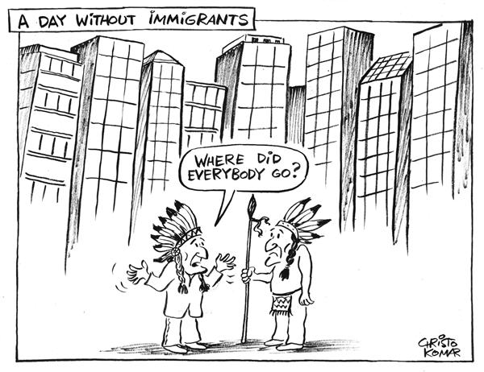

1. Describe what this cartoon has to do with migration/immigration in the U.S.

2. Why are there no other people in this photo, and “why’ are they not there?

