Argumentative, Essay, Opposing View, Paragraph 4 Chart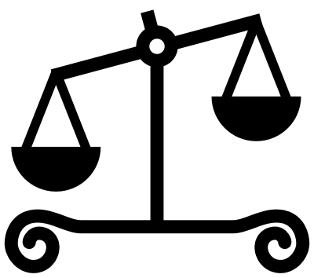

Assertion: On the other hand, some people believe_______________________________________________
______________________because_____________________________________________________.
Opposing claim. | Evidence for opposing claim. | Argument to counter opposing claim. (Why they are wrong and you are right). | Analysis:  Explanation of argument to counter the opposing claim.
A: | 1. | Transition:________________________  1.
B: | 2. | Transition: ________________________  2.

Conclusion: In conclusion, it is apparent that ________________________________________________________________________________.

