Chapter 20 Study Guide | Name _______________________________

- The dots on the timeline represent about when Buddhism arrived in four different countries: India, Korea, China, and Japan. In what order did Buddhism arrive in these countries?
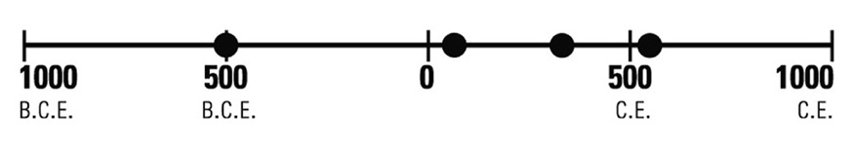1st_________________2nd__________________3rd_________________4th____________________
- As a result of foreign influence, Japanese began creating sculptures of ____________________________________
- Which of these things most affected Japan's contact with other peoples?
- Japan was made up of islands.
- Japan had no central government.
- Japan was a land of farmers.
- Japan had only one religion.
- Who in Japan would have been most upset by the Taika Reforms? ________________________________________
- A shrine built to blend into its natural surroundings would be associated with what religion? ______________________
- What was the relationship between Chinese and Japanese writing?_________________________________________
- What is an example of cultural diffusion as it applies to Japan? _____________________________________________
- How did gagaku, Chinese court music, influence music in Japan? __________________________________________
- Which country influenced Japanese government starting in the 600s? _______________________________________
- How was Japan's capital, Nara, similar to China's capital, Chang'an? ________________________________________
- What religion came to Japan from China by way of Korea? ________________________________________________
- Whose written language did the Japanese adapt to form their own? _________________________________________
- Japan's earliest literary works were modeled after China's. What type of writing were they? ______________________
- How did Japanese sculptures of the Buddha typically differ from Chinese sculptures of him? _____________________
- What were Japan's Buddhist shrines called? ___________________________________________________________
- When Japan imported music from China, what else did they get? ___________________________________________

Follow the directions to complete the item(s) below.

- Each diagram shows one element of culture. In each "China" circle, write what the element was like in China. In each "Japan" circle, write what the element was like in Japan before Chinese influence. In the third circle, write what the element became in Japan as a result of Chinese influence.
