Chop and calligraphy Design a personal chop:

Use small potato, cut it in half, use nail to take out the extra staff

http://www.chinatownconnection.com/chinese_chop_engraving.htm

The Art of Chinese Chop Engraving 中国的篆刻艺术
A sentence frequently heard in the everyday life of a Chinese is "Please sign your name and put your chop on it." You need your name chop to withdraw money from the bank, to pick up a registered letter from the post office, to legalize a contract, and to acknowledge receipt of official documents. In China, from ancient times to the present, from official government business to private affairs, no matter how important or trivial, your chop affixes your credit and your promise. After signing your name, your chop is still required for a document to be legally binding. Name chops are also the constant companions of Chinese calligraphers and painters. Artists follow the custom of stamping their works with their name chops to "sign" them and as proof of authenticity. Despite its small size, the chop plays an extremely important role in the life of a Chinese.
Name chops are engraved by hand. Through the technique of carving, name chops combine the beauty of written Chinese characters and line drawing. A name chop produces virtually the same image of the same characters or figures no matter how many times it is used, and so can be considered a forerunner of one of the four great inventions of the Chinese--printing (the other three being the compass, gunpowder, and papermaking). Its importance cannot be underestimated.
Traditionally, the most common materials for making chops were copper, for the general population, and jade, for the emperor and nobility. Both copper and jade are highly durable materials which must be slowly and carefully cast or ground by an expert craftsman in a very exacting process. By the end of the Yuan Dynasty (1279-1368 A.D.), however, the great painter Wang Mien began to carve his own chops from pyrophylite, a relatively soft mineral. When a skilled calligrapher himself carves a chop, not only does the beauty of the calligraphy come through, but the special effect achieved by knife carving as opposed to grinding is a particularly pleasing one. This method of chop carving soon became very popular among the literati of the time, who later added a new feature to the chop : a poem that could be recited or chanted was written on one side of the chop, based on the artist's feelings and surroundings when he carved the chop. Or he might simply record his name, hometown, and the date on which the chop was carved. The embellishment reveals a great deal about Chinese artistic life of the time. Due to vigorous promotion by literati over the centuries, the art of chop engraving in time joined traditional Chinese calligraphy and painting to form a three-way partnership of the fine arts in China.
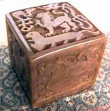
The most important part of chop carving is the engraving of the stamping surface. And half the task of carving a chop is done once the calligraphic style has been chosen, and the arrangement of the characters decided; this is called the "composition" of a chop. Carving the characters with skillful, confident cuts is called "knife technique." The marriage of these two techniques results in a totally new form of written expression, referred to as "calligraphic technique." Chop engraving that is of a certain standard or higher displays excellence in the three areas of "composition," "knife technique," and "calligraphic technique." To further increase the refinement and beauty of the chop design, chop engravers may, in addition to carving the stamping surface, create an elaborate sculpture on the top of the chop, or cut out a scene on the sides in shallow relief. Or they may sculpt a unique and breathtaking original design into the chop based on the natural grain and coloring of the stone used, further increasing the artistic value of the chop. The combination of two and three-dimensional art on a chop gives it special artistic depth and sophistication
After a chop has been engraved, it must be pressed into red ink paste, then stamped onto paper before it becomes an object of practical use; so red ink paste is an indispensable implement in chop art. Red ink paste is made from cinnabar, a mercuric compound. The most important feature of red ink paste is its hue and luster; good ink paste has a brilliant, lustrous red color that retains its original beauty over the ages. Porcelain is the most ideal material for the ink paste container. Ink paste must be frequently stirred with a stirrer so that the oil does not separate to the top, leaving dried out paste underneath. Those who take their chop implements seriously store the ink paste container in a wooden or satin tapestry box to protect the paste from accidental bumps or knocks.
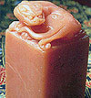
The art of chop carving is highly venerated China. Chops constitute an independent category in fine arts exhibitions, and classes in chop art are held in college and university art departments around the country. There is a privately administered Chop Engravers' Association of China that puts out publications and holds lectures, seminars, and exhibitions to vigorously promote interest in this unique Chinese art. There are also study sessions led by an instructor, or discussion gatherings held among people involved in chop art; or sometimes imprints from chop creations are published in book form and exchanged as gifts. Chop art provides opportunity for quiet and satisfying leisure activity that is well worth promoting among the general population.
In China, chop art is not only a form of artistic expression, the ubiquitous chop engraving shops that dot the country attest to its practical nature. Commonly seen in chop engraving shops are uncarved chops made of wood, stone, metal alloys, and synthetic fiber that the customer can pick from according to personal preference and need. An even wider selection of calligraphic styles is his for the choosing, from the traditional seal script, or chuan shu, to clerical script, or li shu, to regular script , or k"ai shu, to the various scripts designed exclusively for use in chop engraving, such as the "bird," "insect," and "phoenix" styles--and on to an endless number of further styles and variations. The swelling stream of tourists and students coming to China has sparked foreign interest in chop art; a one-of-a-kind name chop is a highly personalized and unique souvenir to keep and treasure. This uniqueness assures the continued thriving of this art regardless of geographical boundary or passage of time.
http://www.chinapage.org/calligraphy.html

Appreciation of
The Art of Chinese Calligraphy
http://afe.easia.columbia.edu/china/language/callig.htm
- Reading: Chinese Calligraphy
- Discussion Questions
- Exercise: Calligraphy in the Classroom
- Exercise: Chinese Calligraphy (Numbers 1-10)
- Practice Pages for Writing Chinese Numbers 1-10
1. Oracle Inscriptions
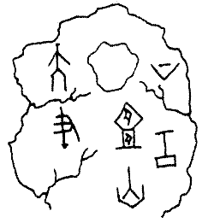
2. The Great Seal Style

This term covers a broad range of styles which came into use during the Chou dynasty (1122- 221 B.C.). Compared to the Oracle Style, these characters are more rounded at the corners and show a mixture of thick and thin strokes. Many of the surviving examples of this style, such as the one below, come from inscriptions that were cast on bronze vessels. At the bottom of the first column is the pictograph (picture-word) for "house." The first word in the second column is also a pictograph. It shows "carriage" from a bird's eye view - a compartment with two wheels on either side, joined by an axle.
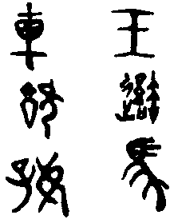
3. The Small Seal Style
In 221 B.C. the first unifier and emperor of China ordered that the writing system be standardized and established the writing style of his native state, Ch'in, as the model script of the empire. The round contours of this script, later known as the Small Seal Style, make it similar to the Great Seal Style. However, the lines are all of an even thickness and the characters are very elongated so that they might be imagined to fit neatly into a vertical rectangle.
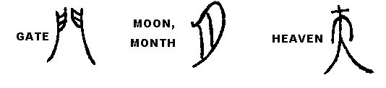
- Clerical Style
During the Han dynasty (207 B.C. - 220 A.D), the Small Seal Style was surpassed in popularity by another script which could be written more quickly and easily with a brush. This style became known as the Clerical Style because more of the samples of this script were found on official documents such as government records of taxes, census records, deeds, etc. Notice the upward tilt at the end of the horizontal strokes which gives each character a fluid quality. This style is the forerunner of the Regular Style which we will look at next.
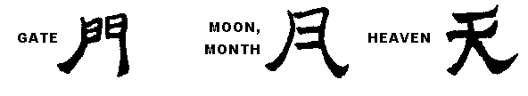

- Regular Style
The Regular Style preserves the Clerical script's precision and modulation of line width but is less formal and heavy in appearance. Note that the horizontal lines generally slope upwards but do not have the final tilt at the end of the stroke which the Clerical Style has. Note also that the vertical lines are kept strictly vertical and do not lean away from the center of the character as in the Clerical Style. As students of calligraphy have traditionally mastered this style before attempting the others, we will also use it as our model in learning to write Chinese.
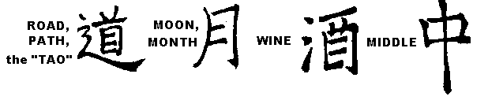

Running Style
As the name suggests, this style allows for more freedom and fluidity in movement. The strokes and dots that are written separately in the Regular Style are joined together in a single sweep of the brush, thus producing a feeling of speed and fluency.
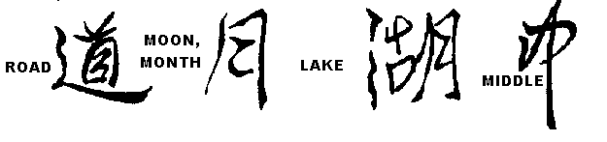
Styles 1 through 4 are called "archaic" styles because they are no longer in use, except for special artistic purposes. Styles 5 and 6 are both in common use today and are called "modern" styles, although historically they have been practiced since the end of the 5th century A.D.
| back to top |

Discussion Questions and Exercises
1. "Be a scribe in order that your limbs may grow smooth and your hands soft, that you may walk abroad in a white robe and that men of importance may great you with respect… the profession of scribe is more profitable than any other profession. It makes you exempt from manual labor. There is no need to carry a hoe, a pickaxe or a basket, or to row a boat. Your life will be free from care."
These words of a schoolteacher in ancient Egypt were used to encourage his students to read and write well. In Egypt, as in China, only a small number of people were able to read and write. What does the above quote tell you about the society's values? If literacy enabled a person to have a good job and to gain the respect of society, why didn't everyone learn to read and write?
Considerations the teacher might bring up:
- The possibility that education was not open to some because of sex, class background, etc. Contrast the concept of education as a privilege with the concept of education as a right.
- The possibility that writing was used only for a few, special purposes (such as the oracle inscriptions) when it was thought necessary to have a permanent record of an event.
2. To what extent is your writing style determined by the instruments you use?
Specific questions the teacher might ask to encourage discussion:
- What kinds of lines are more easily made with a sharp instrument? Straight or round? Ask the students if they have ever tried to carve wood or carve letters on other types of hard surfaces.
- What are the advantages (and drawbacks) of writing with a pencil? A ballpoint pen? A felt tip pen? A fountain pen? Is any one of these tools more convenient to use than the others? Talk about such factors as speed of writing, expense of the tool, ability to correct mistakes, durability of the tool. In what situations would any of these instruments be preferred over the others? How do these tools compare with a brush? (Students might want to answer this last question after the calligraphy practice in Part II.)
3. Is good penmanship important in our society? Is it sometimes regarded as an art? How about the case of commercial lettering, the style and layout of lettering in advertisements and billboards?
4. Test your eye! Can you identify the styles of the following characters? (The meaning of each set of words is given at the beginning of the row.)
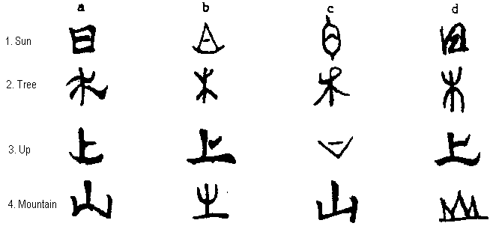
Answer Key
- a. Regular b. Oracle c. Sm. Seal d. Running
- a. Clerical b. Oracle c. Running d. Sm. Seal
- a. Gr. Seal b. Regular c. Oracle d. Clerical
- a. Clerical b. Sm. Seal c. Regular d. Oracle
| back to top |
http://depts.washington.edu/chinaciv/callig/callmain.htm script type
In China, the style in which an individual writes has long been believed to communicate something essential about his or her personality, intellect, and abilities. Even today it is a common presumption that one can "read" the identity of the person through his or her handwriting.

Young man practicing calligraphy source

The European term calligraphy means "beautiful writing," and reflects an interest in ornamenting words on the page; most European calligraphy is highly stylized, regular, and decorated with flourishes, which in themselves are lacking in personal expression. Calligraphy in the West was always considered a minor art and tended to curb spontaneity, producing fairly static forms.  In China, however, this was far from the case; the most widely practiced writing styles favored spontaneity, and the brush was thought to act like a seismograph in recording the movements of arm, wrist, and hand. East Asian calligraphy was established as a "high art" form well before the Tang dynasty. It has continuously enjoyed a high status among the arts ever since, and is practiced today by many people, including every school-aged child.  This unit will cover calligraphy in China up through the Tang dynasty, with an emphasis on the Six Dynasties and Tang. It was during this period that calligraphy first began to flourish as an art form. By the Later Han, the basic script types had been created, and no new types developed after this time. The first writings to evaluate calligraphic style also date from this period. These texts reveal a notable shift toward seeing an expressive quality in writing that went beyond the mere ability to communicate meaning.  As you go through this unit, keep the following questions in mind:  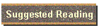 | 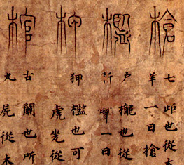
  Why is calligraphy highly ranked as an art form in China?
  How is calligraphy connected to class or status?
  How are the materials and techniques used by Chinese calligraphers linked to theories about calligraphy?
  What types of skills and knowledge are required to appreciate and evaluate calligraphy? Who collected calligraphy, and why?
 | Script Types
 | 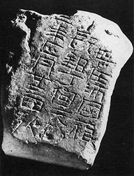
Techniques of
Transmission
 | 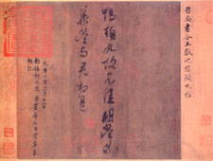
 | Six Dynasties Calligraphy
 | 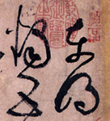
 | Tang Calligraphy
 | 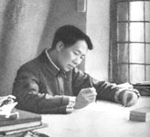
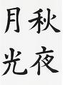楷書 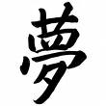草書
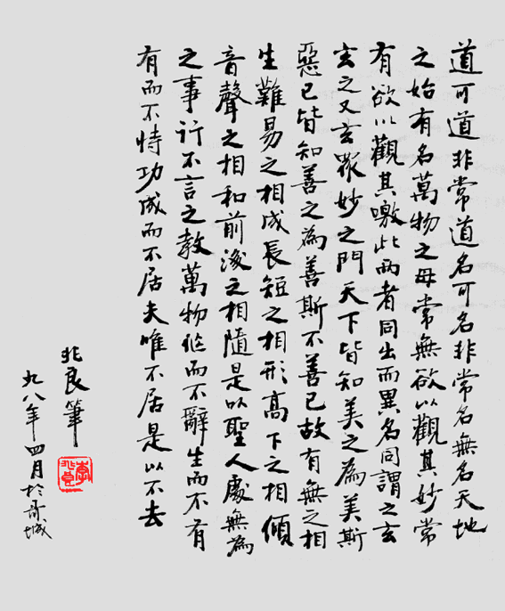

Compare and contrast Ming dynasty painting to renaissance painting
Notes: Big difference:
- Light / shading including modeling (style)
- spatial perspective
- materials used: ink vs. oil painting (invented )
- Calligraphy / name chop on Chinese painting (words and pictures --- three way display) vs painting itself
- ownership stamp
- Loaded with religious symbols vs. well – rounded life
- Similarities: high official status were portrayed on the painting

